**Marketing Campaign Analysis**

XYZ Paints Inc. is a paint company which was recently launched in 2019. Since then, they have established their name in top tier 1 and 2 cities (slowly expanding to tier 3 cities as well).

They have orders coming from household, industrial and government sectors. In recent years, they are seeing quite a steady growth and would like to continue that in future.

Sample of data from their databases : -

**DDL Commands Link :**

[**https://drive.google.com/file/d/1Lhb12TVJSOdlkDIIfTx8aGNa2P9gRhPW/view?usp=drive_link**](https://drive.google.com/file/d/1Lhb12TVJSOdlkDIIfTx8aGNa2P9gRhPW/view?usp=drive_link)

I have to worked on some of the pain points of the marketing team like consumer growth, lead conversions, etc. as well on new set of campaigns or doing market basket analysis.

In this project, I have used MySql workbench to execute my queries. Also I have used google docs in order to present it.

**Data Overview :**

Database consist on 6 tables. In order to better understand the data I have made an schema of the database using reverse engineering in My Sql Workbench.

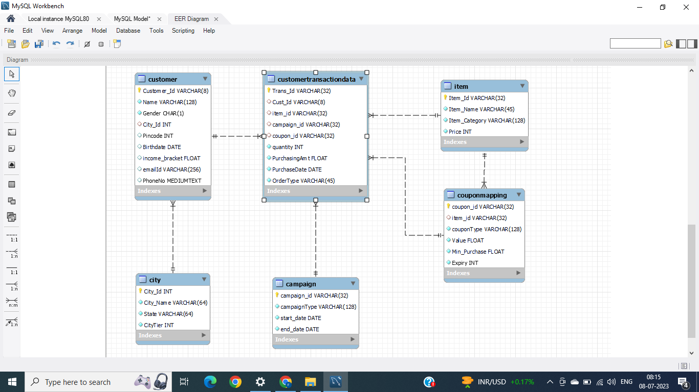

**Data Analysis :**

Here in this section, I have displayed all the questions which I have answered in this project.

**Queries used** :

To write queries answering all of below questions in MySQL , I have created a Database in MySQL Workbench. I am attaching the file for all the Queries which I have used to answer all the questions in both .sql and .txt format.

.txt link - <https://drive.google.com/file/d/118vPqjgDVUkfjLBPriT4YQ-SfuV8ACIK/view?usp=drive_link>

.sql link - <https://drive.google.com/file/d/1EujufRndMvvhu7nbxGfF1lJsspNMHUa1/view?usp=drive_link>

**Section 1**:

**Q1.** Checking the cardinality of following columns:

* 1. Different color segments (categories) provided by the company.
  2. Different Coupon Types that are offered.
  3. States where the company is currently delivering its products and services.
  4. Different Order Types.

**Q2.** Identifying total number of sales (transactions) happened by

* 1. Yearly basis
  2. Quarterly basis
  3. Yearly and Monthly basis

**Q3.**. Identifying the total purchase order by

* 1. Product category
  2. Yearly and Quarterly basis
  3. Order Type
  4. City Tier

**Section 2 :**

Here in this section I have tried to understand the customer path to conversion as a potential purchaser based on our campaigns.

1. Identifying the total number of transactions with campaign coupon vs total number of transactions without campaign coupon.  
2. Identifying the number of customers with first purchase done with or without campaign coupons.  
3. Identifying the impact of campaigns on users.

* + Check the total number of unique users making purchases with or without campaign coupons.
  + Check the purchase amount with campaign coupons vs normal coupons vs no coupons.

**“Based on the above analysis, I have observed that Campaigns were very effective in adding new customers. They also accounted for maximum share in total revenue of the company.”**

**Section 3 :**

In this section I have tried to help the marketing team in understanding the growth and decline pattern of the company in terms of new leads or sales amount by the customers.

1. Identifying the total growth on an year by year basis excluding the current year

1. Based on quantity of paint that is sold.
2. Based on amount of paint that is sold.
3. Based on new customers that are acquired.
4. Segregating new customers by OrderType

**“Making an analysis of what is happening with our customer acquisition and sales growth over the years. It can be observed that the total quantity sold per year, first increased in the year 2020 by more than 100%. However, it showed a negative trend in the coming years, which is 2021 and 2022. Similar pattern can be observed in Total revenue collection and new customer acquisition.”**

2. Identifying the total decline, if any, within the total sales amount on an year by year basis excluding the current year.

3. Commenting on whether we need to launch a campaign for the consumers based on the recent pattern.

**“There is a significant decline in Total Sales of the company. Hence, there is definitely a need to launch more and more campaigns. In Section 2 we have seen that campaign coupons proved beneficial in acquiring new customers and increasing total sales. Looking at above data it is clear that Brand Awareness and Seasonal Push Campaign will prove most beneficial.”**

**Section 4 :**

A market basket analysis is defined as a customer’s overall buying pattern of different sets of products.

The marketing team wants to understand customer purchasing pattern. Their proposal is if they promote the products in their next campaign, which are bought couple of times together, then this will increase the revenue for company. In order to answer their question I have tried to answer these questions given below.

* 1. Identifying the dates when the same customer has purchased some product(same order types and different products) from the company outlets.
  2. Out of the above, identifying the same combination of products coming at least thrice sorted in descending order of their appearance.
  3. Out of the above combinations (coming thrice), checking which of these combinations are popular in different sectors (household, industrial and government).

On the basis of above three, highlighting the combinations of products that are bought couple of times in data on the same day. Also, identifying which combinations should be promoted/advertised together to these different sectors for maximum growth.

Overall:

1. White emulsion paint + Navy blue emulsion paint (7 times)

2. Soft red synthetic paint + Cream Emulsion paint (3 times)

3. Green sage enamel paint + Soft Green Oil Paint (3 times)

Category Wise:

1. Household - White emulsion paint + Navy blue emulsion paint

2. Household - Soft red synthetic paint + Cream Emulsion paint

These combinations should be promoted together to given sectors.

**Section 5 :**

Company is thinking of launching a new campaign in upcoming months. Here I have automated the following tasks.

1. Created Functions for the following:

* + Getting the total discount, if any.
  + Getting the days/month/year elapsed since the last purchase of a customer depending on input from user.

2. Createing Views (using above functions) for the following:

* + Identifying the top 10 customers along with their demographic details from each sector based on their total discount.
  + Identifying the top 5 customers (from household and industrial sector) based on purchase amount and days elapsed in descending order.
  + Identifying the top 10 products that are sold last year based on sales amount along with the last 2 year details of the same.
  + Creating 3 different income groups for household sector people - ‘high class’, ‘low class’, ‘middle class’ - based on their percent rank (33% each) and identify the top 2 products that are bought within these income class.

3. Creating Stored Procedures for following data validation tasks:

a. Identifying whether a particular transaction amount (purchase amount) is ‘correct’ or ‘not correct’. (It is correct if price and quantity are used to calculate without a coupon. In case of a coupon, the coupon amount should be deducted from the original amount given the original amount is greater than equal to min purchase for a coupon; else you can simply calculate original amount based on quantity. )[Input is transaction id]

b. Checking if there is any customer with age < 12. Printing out the total such customers on-screen.